Week 2 Lab Task
Information Gathering (OSINT)
NIAI NAVTTC — Certified Ethical Hacker (CEH) Course
⚠ Important: If the Provided testphp.vulnweb.com is unreachable You can use any other target for information gathering purpose

Task: Investigate a suspicious domain. Analyze domain registration details, check for potential malicious activities, and provide actionable intelligence for an incident response team.

▶ Choose a Safe Practice Domain
Use testphp.vulnweb.com — this is a deliberately vulnerable site made for training.
DO NOT target real websites or domains without explicit written permission.
▶ WHOIS Lookup — Find Domain Owner
Run in Kali terminal:
whois testphp.vulnweb.com
Note the registrar, creation date, name servers, and contact details.

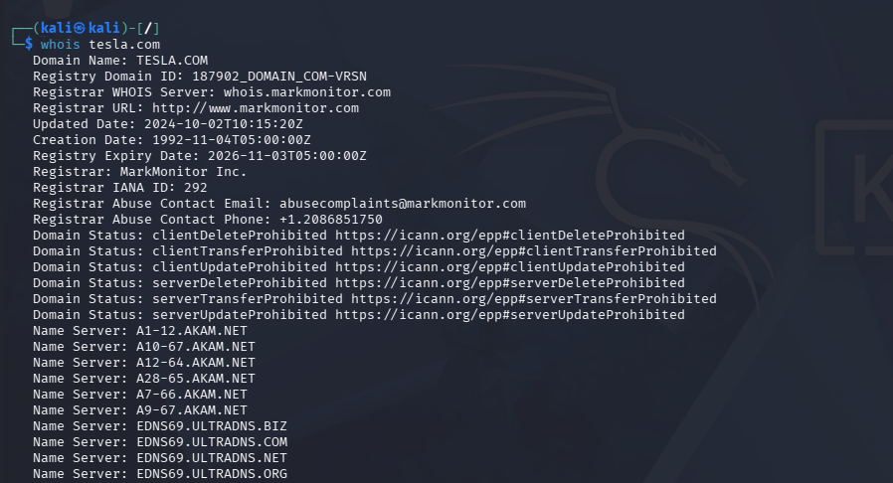

▶ DNS Enumeration
nslookup testphp.vulnweb.com
host testphp.vulnweb.com

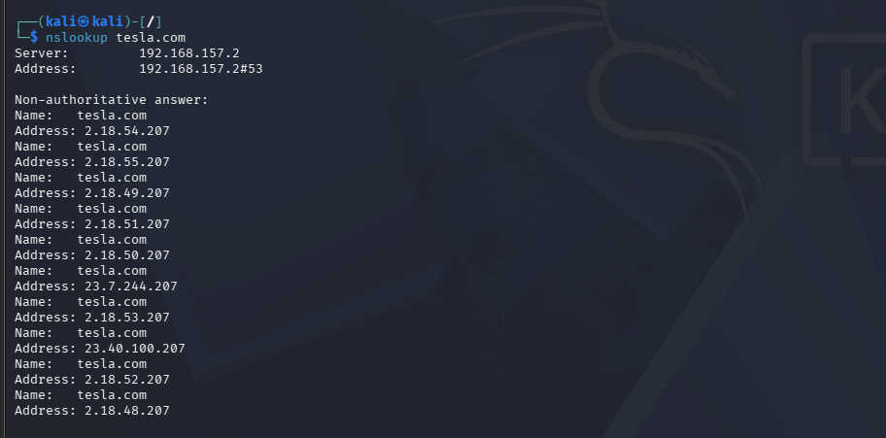

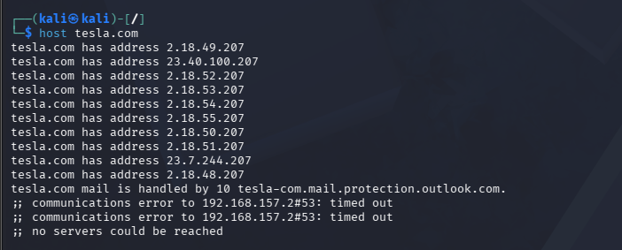

▶ Shodan — Check Exposed Services
Go to shodan.io in your browser.
Search the domain name or its IP address.
Note what ports and services are publicly visible (e.g. open port 22, 80, 443).
▶ Google Dorks — Find Indexed Pages
In Google browser, search:
site:testphp.vulnweb.com
intitle:index.of testphp.vulnweb.com
▶ Write Your Intelligence Report
Document the following findings in a structured report:
- Who owns the domain? (WHOIS data)

- What IP addresses are associated?
- What emails or subdomains were found?
- What ports/services are exposed on Shodan?
- Any suspicious indicators?

1. Domain Ownership (WHOIS Data)
The WHOIS lookup reveals the following information about the target domain:
- Registrar: [e.g., Namecheap / GoDaddy]
- Registration Date: [Insert date]
- Expiry Date: [Insert date]
- Organization / Owner: [If available, otherwise “Redacted for Privacy”]
- Name Servers: [List name servers]
- Contact Information: [Usually hidden due to WHOIS privacy protection]
Analysis:
The domain ownership appears to be [legitimate / anonymized]. The use of privacy protection may indicate standard security practice, though it can also obscure attribution.

2. Associated IP Addresses
The following IP address(es) are linked to the domain:
- Primary IP: [Insert IP]
- Additional IPs (if any): [List]
Analysis:
The IP address is hosted by [Hosting Provider / ISP]. This suggests the infrastructure is [cloud-based / dedicated / shared hosting].

3. Emails and Subdomains Discovered
Emails Found:
- [example@domain.com]
- [admin@domain.com]
Subdomains Identified:
- [mail.domain.com]
- [api.domain.com]
- [dev.domain.com]
Analysis:
The presence of these subdomains indicates [development environments / internal services / email servers]. Exposed emails may increase the risk of phishing or targeted attacks.

4. Shodan Results (Open Ports & Services)
The Shodan scan revealed the following exposed services:
- Port 80 (HTTP): Web server running [Apache/Nginx]
- Port 443 (HTTPS): Secure web service with SSL/TLS
- Port 22 (SSH): Remote access service
- Port 21 (FTP): File transfer service (if open)
Analysis:
Open ports indicate publicly accessible services. Services like SSH or FTP, if not properly secured, may present potential entry points for attackers.

5. Suspicious Indicators
The following observations may indicate potential security concerns:
- Use of WHOIS privacy protection (limits attribution)
- Presence of unused or test subdomains (e.g., dev, staging)
- Open sensitive ports (e.g., SSH, FTP)
- Outdated server versions (if identified)
- Lack of proper security headers or misconfigurations
Overall Assessment:
The target shows [low / moderate / high] risk based on exposed services and available information. Further investigation or vulnerability scanning may be required.

🎯 Goal: Produce a structured intelligence report on a domain including ownership, DNS records, exposed services, and any suspicious indicators of compromise.

